For the purposes of the DAC AMP design, we are focusing on the base requirements and working through what we need to use for the device to meet those requirements. To begin with, our requirements are to have good quality audiophile grade output from USB. The output we would need to use to get this audio quality was unknown, so we began with some research on that.
According to many sources that we could find, the vast majority of users could not differentiate any audio quality difference between any signal qualities above 16-bit and 96KHz response rating. For real world devices, studio grade equipment still attempts to produce truly “Lossless” audio by producing a signal with a 32-bit depth and a 768KHz sampling rate in order to get as close as possible to the reference waveform. When looking at the market of these studio products, they are often for musicians or those who rely on audio for their work. This means that our “acceptable quality range” is from that 16-bit 96KHz quality to 32-bit 768KHz. We do not need the extra difficulty of reaching that lossless range as we do not intend to use this device in a studio environment, so reaching the top end of the range is not a priority. This range puts us within the USB Audio Class 2.0 range, which also affects which specific ICs we can use for interfacing.
The next step was to research how to get this signal out from the computer into the headphones or IEMs being used for playback. The overall audio stage understanding that we have coming in is that an there are two core steps; the Digital to Analog Conversion to produce the signal, and the Amplification of incoming Audio Signal in order to feed it to the output device. Having this understanding coming in aided in narrowing down our approach. The amplifier has is its own analog design considerations based on the expected load, so for now we will be limiting our view to the Digital to Analog Conversion stage. Our first step was to see what was available as an IC already. On supplier websites, there are several ICs that handle a full USB to Audio signal conversion in the chip. These chips all fall outside of our acceptable bounds of audio quality though. The sampling rate that the chips seem to be limited to is 48KHz, and there are very few Active chips available, with most options being obsolete or Not for New Designs.
If we cannot handle the full USB interfacing and the conversion Digital Audio to Analog Audio within a single IC, we can distribute the roles. With this setup, there would be an initial IC which accepts the USB Audio Class 2.0 input, and this IC would act as the USB interface while outputting a digital audio signal. This leads us into the main design consideration that will affect the types of devices we can use; the communication protocol which we use for the audio interfacing. There are a couple of different options here. The most familiar option would be a standard microcontroller protocol such as SPI, or Serial Peripheral Interface. This has the advantage of being more widely documented and supported, but has the drawback of being more general purpose. SPI is a high speed bus protocol meant to contain multiple devices on the same bus, with lots of features to prevent data collisions and proper data reliability. None of these benefits to SPI matter for our application, as the plan is to have minimal devices on board.
If the general-purpose protocols don’t benefit our application, then we can shift to looking at more purpose built protocols. One available protocols we could use is known as S/PDIF, or the Sony / Phillips Digital Interface. This protocol has the advantage of being able to communicate over a single coaxial input and being more robust to send out at a range. It is a protocol which microcontrollers can support, but parts are a bit more expensive relative to other options and the input is limited to 24-bit 192KHz. This itself shouldn’t be a dealbreaker for use of S/PDIF, and the ability to send output of the signal through an optical cable is a very big advantage. A large downside to S/PDIF is that it does use that single communication line which allows it to be sent over optical. The clock signal for communication is internal to the data being sent through the wire, and the receiving side needs to get the clock signal using a PLL. This adds extra overhead and design complexity for a situation where the long-distance communication benefit is not needed.
There is another robust Digital Audio interface available known as I2S, or Inter-Integrated Circuit Sound. This protocol was developed specifically for audio interfacing and can support full speed audio up to any point within our requirements range. I2S has the perk of using a clock to send bits and synchronize the information that needs to be sent to DAC. This clock can be configured such that a high frequency, low jitter, low phase noise clock can be implemented into the I2S bridge, which when implemented, results in a similar high performance I2S signal with little to no harmonics as shown in a test below from forum.headphones.com, where the only harmonic present is the output frequency of the speakers. The second figure below shows the same output through USB. The issue with using USB is that the system receives bursts of information every millisecond or so, rather than receiving a bit per stable cycle. This results in non-uniform sampling that can cause noise. Due to the benefits that I2S gives in our small scale implementation, we will be going forward with it as the core of our design. If we want to utilize S/PDIF, the best way to do that would be to add a TOSLINK connector to allow for external interfacing. This makes the most of both protocols, as we can utilize the I2S for the high quality audio to the DAC which does not have to leave the PCB, and then the S/PDIF can be used at range for an external speaker connection.

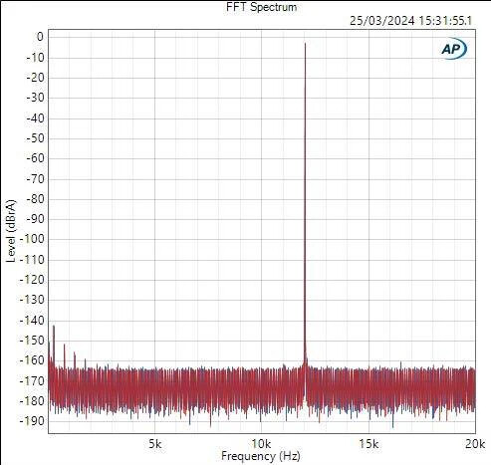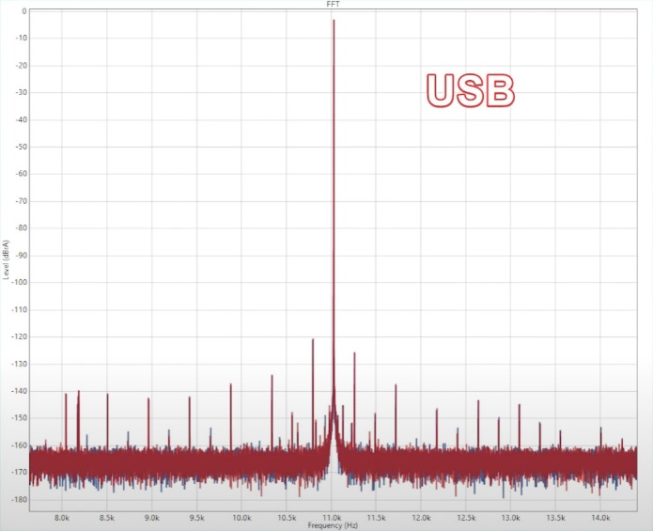

This means that in order to go with an I2S setup, we would need to utilize a specific device to convert from the USB 2.0 signal to the I2S digital audio signal. A search for a simple USB to I2S bridge IC shows several options from Silicon Labs, such as the CP2615. The two core reasons these ICs would not work for us though is that they are all obsolete, and none of them support the full USB Audio Class 2.0 that would be needed to get the HiFi signals we want. Because they were obsolete, our next step is to investigate the recommendation for new designs, which in our case was EFM8UB20F32G. This new device is an entire microcontroller with many peripheral options, but there was not much information on its application as an I2S bridge easily available, and we could not find any commercial devices which utilized it.
When researching commercial topologies, there were 4 main microcontroller brands which are used. Qualcomm is very common to see in available products, but that is due to these SOCs being easily able to run the Bluetooth stack. This capability is not needed in our case, and the Qualcomm SOCs are also not available for consumer purchasing, and the only way we can get it is through dubious resellers. Amanero is another bridge which is used by production models, but it suffers from the same lack of availability that the Qualcomm does. Another microcontroller which is used often is the STM32. The only concern with the STM32 is that the clocking scheme is somewhat rigid, and if multiple clocks are used on the circuit board there will be a separate set of components needed to handle that. The clocking scheme that is necessary is not known at this time, so the best bet would be a more flexible option, such as an XMOS. A variety of devices supporting audiophile outputs utilize an XMOS XU208, but that device is currently obsolete. The new design device is the XU316, which can output any peripheral we need through software. The microcontroller can handle our entire potential audio range up to the lossless range.
As for the DAC itself, we were now limited to I2S capable DACs. If possible, we would like to be able to handle our entire audio quality range to allow for flexibility on what the end implementation is. When researching user opinions on DACs that are good quality for the cost, the primary line that appears are Sabre Audio branded DACs. DAC AMPs labeled with Sabre Audio utilize the ESS Sabre DACs, of which the current generation is the ES9039. This DAC has two available variants of the Q2M and the Q8, where the difference is two channel vs eight channels. The eight channel variant is intended for multi output applications, which we do not need for this use case. The ES9039Q2M therefore is our final selected DAC.

